YETIS ISC FUNDRAISER ITEMS
Contact Audrey Rider at 605-450-0191 – audreyjopazour@yahoo.com
Or a YETIS member (see list on SDSA website) to order these items.
They can be shipped directly to you for a minimal cost.
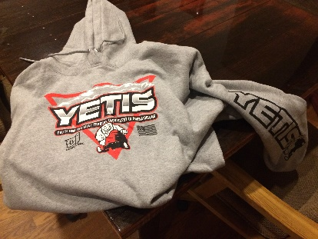
T-shirts $15

Hooded sweatshirts $40
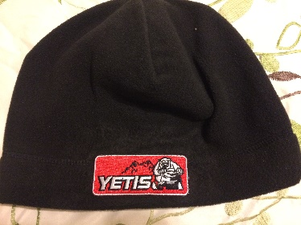

Beanies/Stocking Hat $10

2018 SDSA sticker $2 or 2/$3
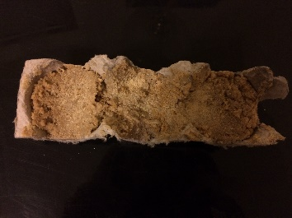

Fire Starters $5 for pack of 3

The YETIS want to send many of their members to ISC 2019 in Michigan!

